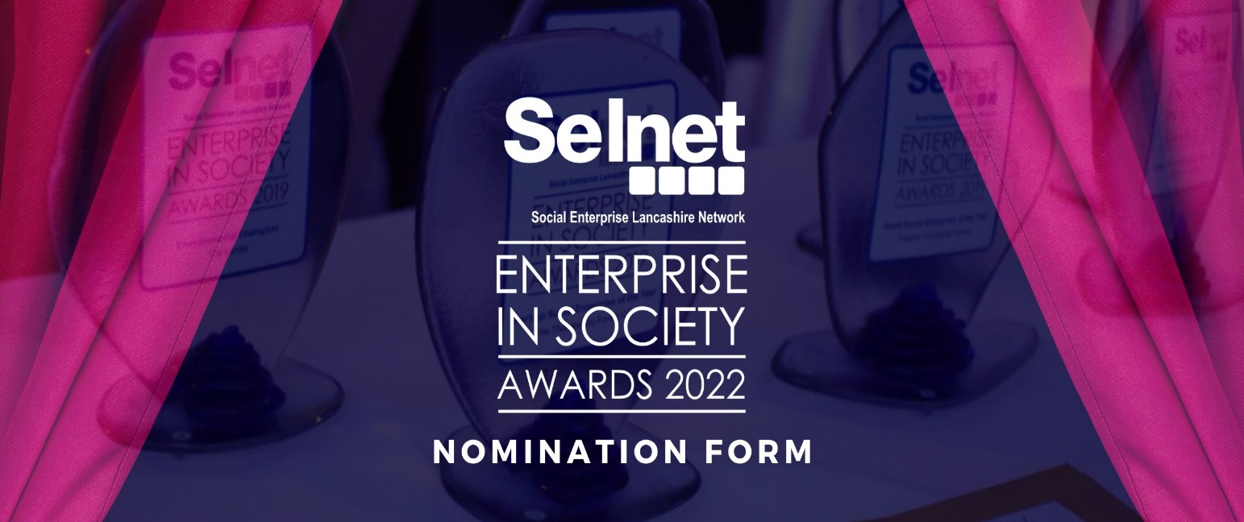

Applicant Details

Please provide correspondence details for the person making this application. These details will be used to communicate with you regarding this application, any event updates or to raise any queries ahead of the award judging process.

Contact Name
Email Address
Direct contact number/mobile

Nomination & Category Information

Full category guidelines including what the judges will look for under each category can be found at:
www.awards.selnet-uk.com/categories

Who is the nomination for?

Company Name or Individual
Category Entered (select from dropdown) | Choose an item.

NB: You must complete a separate application for each category you wish to make a nomination for – this is to ensure your nomination has the best chance of success.

REMEMBER:
Your nomination should focus on how the work you do benefits society and its wider impact for Lancashire.
We ask independent judges to form an opinion of all the nominees within each category. The judges may not know your organisation and the content within your application is all they have to assess the most worthy winner of an award.
Make sure you tell them everything you want them to know!
Tell them how you:
- Have made an impact and achieved your goals
- Increased or have sought opportunity/s to increase turnover and secure future sustainability i.e. new services developed, or contracts awarded
- Expanded or consolidated the business
- Considered the environment

Please email your completed form to awards@selnet-uk.com before the new closing date of Tuesday 27th September 2022 at midday. You will receive an email confirming your submission within two working days. If this is not received, please call Yvette (Membership Lead Officer) on 01772 200690.

Nomination Details

Tell us about the organisation and its business activities
Give a brief overview of the organisation being nominated. Outline its social mission as well as its business activity. Tell us how it earns its income or where contracts come from and explaining the business model.
0/250 max
Social or environmental purpose and impact
Summarise the social or environmental purpose of the organisation and provide an assessment of the difference made through this organisations work.
0/250 max

Your nomination details
Tell the judges everything they need to know to understand why your nomination is worthy winner!
0/500 max

Supporting Documents

You are welcome to provide up to 3 pieces of supporting documentation such as, testimonials, annual reports, evidence of impact reports or anything else that is relevant to support your application. Please note that in all cases file names should be succinct, begin with the nominee name and the file size to be 10MB maximum.
Please list your supporting documents:
1.
2.
3.

Declaration

- You declare that the information given in the above sections of this application is a true and accurate representation of your organisation or your nominee. If any of the information is found to be incorrect that affects eligibility for a Social Enterprise in Society Awards 2022 category application, Selnet have the right to withdraw your entry.
- You understand that the selection of the successful applications will be within the sole discretion of the panel of judges and Selnet and those decisions by the judges and/or Selnet are final.
- By completing the fields below, you agree with the above declaration. The fields must be completed by a person authorised to make this application.

Name:
Position:
Date:

Data Privacy
In order to process your application and keep you informed about the judging process, results and subsequent event information; we require clear consent from you to process the data you have supplied to us. This data will be collected, retained and securely processed by Selnet strictly for the purpose of administering the Social Enterprise in Society Awards 2022. Data which has been gathered through this application is required for the organisation and administration of the Social Enterprise in Society Awards 2022 and will be transferred from Selnet to Judges who will retain your data in line with the appropriate data retention policies. Your contact details are required so we may correspond with applicants regarding the status of your submission, the associated event and future Selnet events. After giving consent for your data to be processed in this way, you may at any time withdraw your consent or request any clarification on how your data has been processed.
You can view Selnet’s privacy policy here - www.selnet-uk.com/privacy-policy

I give my consent ☐

