Tuesday 17th January 2023
10am - 2pm
Blackburn Cathedral

1. Exhibition Stand Booking Information
Thank you for your interest in booking a stand at our Social Business Expo. This Expo has been organised to bring Social Enterprises from across Lancashire to join together to network, hear from topical speakers, and promote your business.
Included in this exhibitor package you will receive:
- Gopak Folding Table (Dimensions 6ft x 2.5ft)
- Two chairs
- Space for a banner
- Packed lunch (for 2 people)

Details of assembling & dismantling:
The Cathedral is closed on Monday which means exhibitors can go in, the day before the event to set up their stand(s) anytime between 10am and 1pm on Monday 16th January.
Yvette Holden will be on site to allow access to the Cathedral. Please call her mobile on 07958 432165 when you arrive.
You will also be able to set up early on Tuesday morning before the event starts, but you must be aware, if you plan to set up on Tuesday (the day of the event) this can only be done between 9am and 9:30am
**there is a service being held at the Cathedral at 8:30 till 9:00am that we must not interrupt**

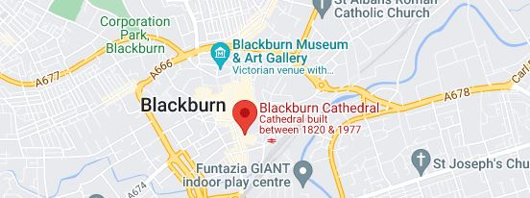
Map & Directions to Blackburn Cathedral:
The Cathedral is at the heart of Blackburn Town Centre and surrounded by convenient on-street car parks. Sat Nav users should use postcode BB1 5AA
(click map for google maps)
The map is clickable and will connect you to Google maps
(Internet connection required)

2. Exhibitors Cost and Payment Details
There will be a small charge for exhibiting at the event, a reduced fee for Selnet Members and full cost price for non-members:

- Stand cost for a Selnet member - £25 + VAT

- Stand cost for non-members - £50+ VAT

If you need any information on how to become a Selnet Member, please email: yvette@selnet-uk.com

Upon receipt of your booking form, we will issue an invoice by email to the main contact person you have detailed in section 3 of this form. Please ensure that the invoice is paid upon receipt.
(Selnet do not have card payment facilities so please either make cheques payable to Selnet Ltd or follow the BACS payments detailed on the invoice)

For invoicing purposes please provide the following details:
Company Name:
Invoice address:
Purchase Order No:

3. About you and your exhibitors
Company Name:
Telephone No:
Main contract person:
(Include email and mobile please)
How many staff will be attending the event?
Exhibitor 1
Name:
Mobile contact:
Email address:
Exhibitor 2
Name:
Mobile contact:
Email address:
Twitter handle:
Any special Dietary Requirements
(A packed lunch provided for 2 exhibitors):
Does anyone in your staff team have any access requirements?

4. About Your Organisation
Tell us about the organisation and its business activities
Please give a brief overview of the organisation its business activity. This information will be used in the Expo brochure.
0/250 max

Images
Please attach your company logo & any images you would like to be included

List the images you are attaching to the email:
1.
2.
3.

Please return to: Yvette Holden - Selnet Lead Membership Officer by email to yvette@selnet-uk.com

If you have any questions or concerns, please call Yvette on:
Office: 01772 200690 or Mobile: 07958 432165

