Social Enterprise Peer Network

@SelnetLtd #PeerNetworksLancs #SocEntSolidarity
www.selnet-uk.com/peer-networks/
Register of Interest
‘Peer Networks’ is a national peer-to-peer networking programme for SME leaders that want to grow and develop their organisation for future success.
Lancashire’s Social Enterprise Peer Network programme is organised and
delivered by industry experts Selnet and focuses on overcoming the
unique barriers to scaling social enterprises
‘Peer Networks’ is a national peer-to-peer networking programme for SME leaders that want to grow and develop their organisation for future success. Selnet are excited to be delivering 2 Peer Network cohorts for social enterprises in Lancashire!
This important business support initiative is being delivered as part of a wider Peer Network programme during what has been a tough time for many businesses – with the added dimension of meeting increased community need during such a challenging time.
The programme includes interactive action learning, trained facilitators, small groups, flexible topic selection and one to one coaching for groups of individuals to collaboratively work through common business issues with individual one-to-one needs-led coaching support.
By completing Peer Networks, you will overcome business challenges and recognise and act on new opportunities, build a trusted network of connections to support you now and in the future, and improve your long-term personal and business performance.
Participate in Peer Networks
Participating social enterprises should have a trading address within the Lancashire LEP area and have:
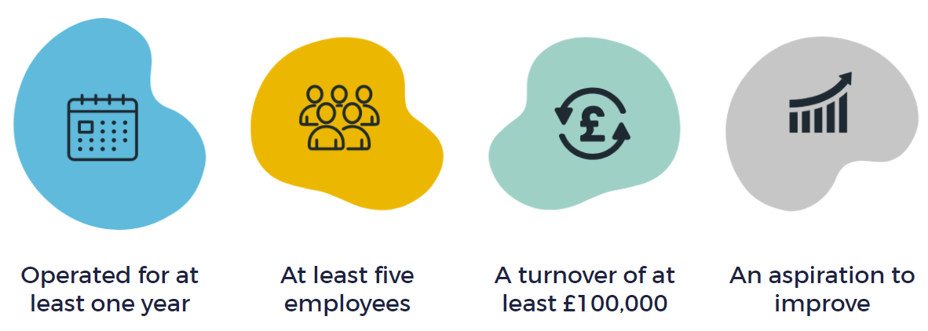
The programme is jointly funded by BEIS and Lancashire County Council
Social Enterprise Peer Networks: Register Your Interest
Contact Details
Lead contact name: | Click or tap here to enter text.
Business address: | Click or tap here to enter text.
Post Code: | Click or tap here to enter text.
Tel: | Click or tap here to enter text.
Mobile: | Click or tap here to enter text.
Email: | Click or tap here to enter text.
Social Media: | Click or tap here to enter text.

About your Social Enterprise
Name of Social Enterprise: |  | Click or tap here to enter text.
Company number: |  | Click or tap here to enter text.
Aims and objectives |  | Click or tap here to enter text.
Date trading commenced |  | Click or tap here to enter text.
Turnover |  | Click or tap here to enter text.
Number of employees |  | Click or tap here to enter text.
Give a brief description of the activities of your social enterprise |  | Click or tap here to enter text.

Trading
What are your main sources of income? | Click or tap here to enter text.
Who is your target market / who are your main customers? | Click or tap here to enter text.
Declaration
BEIS (Department for Business, Energy and Industrial Strategy) & Boost Business Lancashire need to store your data on a database in order to give you the full assistance under this scheme. Please note if you do not agree to us sharing your information we may be unable to offer you full assistance under the scheme.
All information given will be held and only be used in line with the General Data Protection Regulation. We will need to share your information with our funding providers; the Ministry of Housing, Communities and Local Government, Department for Business, Energy and Industrial Strategy, Department for International Trade. It may be necessary to share your information within the business support partnership which includes your Local Authority, in order to offer you the full support service. A full list of the support organisations can be found on our Privacy Policy – https://www.boostbusinesslancashire.co.uk/terms-conditions/privacy-notice/
You should be aware that some information relating to this public funded project may be declared to third parties under the Freedom of Information Act 2000
DO YOU GIVE CONSENT FOR BOOST BUSINESS LANCASHIRE TO: | YES/NO:
Share your information with our funding providers | ☐
Share your information within the support delivery partnership | ☐
Keep you informed via email of the latest funding schemes, projects and events run by the local business support partnerships. | ☐
Use photographs, quotes and/or recordings of, or given by you either singularly or in conjunction with other photographs and/or recordings for advertising, publicity, commercial or other business purposes. These will be used for the promotion of your business and the TWO ZERO programme through case studies, social media etc. | ☐
Where processing personal data is based on consent, Lancashire County Council must be able to demonstrate that you have consented to the processing, and they can do this using this consent form. You can withdraw your consent or opt out of receiving correspondence at any time by using the 'unsubscribe' button, by emailing info@boostbusinesslancashire.co.uk or via the website www.boostbusinesslancashire.co.uk
You will be expected to share information that will allow us to collect the evidence we require. By signing this form, you agree to provide including, but not limited to, growth in value added as an indicator of recovery from COVID-19, improvements in labour productivity, firm survival, changes in the SME’s adoption of technology. To help us quality check and improve our service we will also ask you for your feedback.
☐ I declare that the information given on this form is true and to the best of my knowledge accurate. I understand the outcomes and approve any further action indicated on previous pages.
 | Print Name | Position | Date
Client | Click or tap here to enter text. | Click or tap here to enter text. | Click or tap here to enter text.
 | Signature:
On behalf of Selnet | Click or tap here to enter text. | Click or tap here to enter text. | Click or tap here to enter text.
 | Signature:

