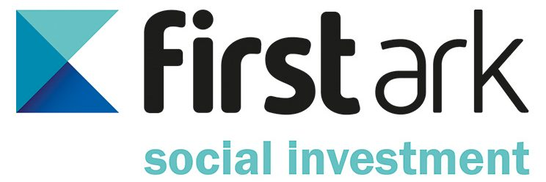
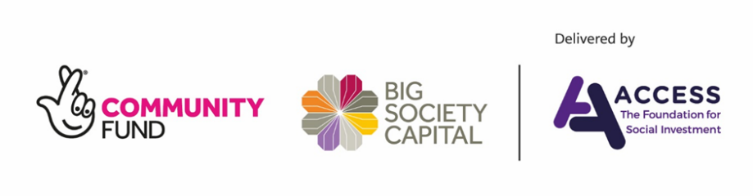

Press release
17 September 2019
Over £2m up for grabs for Lancashire’s social enterprises
Social enterprises across Lancashire are being encouraged to apply for social investment, offered by a Merseyside-based funder, to help them become more sustainable and enhance their social impact.
First Ark Social Investment (FASI) works with social enterprises and charities across the North West and is especially keen to partner with organisations in Lancashire.
FASI, together with Lancaster University and the Social Enterprise Network for Lancashire (Selnet) is offering local social enterprises the chance to attend a free ‘social investment workshop’. Held on 23 September, from 12.30 - 3.30pm, at FASS Meeting Room 2, North Campus, at the University, it will offer individuals face-to-face funding advice, support around applying for investment and there’s an opportunity to listen to talks by all partners.
FASI recently received an additional commitment of top-up funding from The Growth Fund, a partnership between The National Lottery Community Fund, Big Society Capital and Access – The Foundation for Social Investment. This additional backing will enable FASI to offer up to an additional £2.3m in ‘blended’ finance investments, made up of grants and loans, to social enterprises across the North West, including Lancashire.
Léann Hearne, Group Chief Executive Officer at First Ark Group, said:
“We’re looking to work with any social enterprises in the area that promote social investment - from an organisation that upskills unemployed people, to a creative enterprise or sporting venture.
“If you’re wondering about how to grow your social organisation or charity come along to our free workshop at Lancaster University and speak to one of our team and listen to informed speakers.
“Many organisations in Lancashire might not be aware of the funds and strategic support we offer. We’re here to help social enterprises grow, become more sustainable, increase their social value and make a real difference within their communities.
“We’re particularly keen to support organisations in the area and want to raise awareness of how FASI can help create additional social impact and develop financial sustainability.”
Glyn Jones, Commercial Programme Manager at Lancaster University, added:
“Funding is a vital part of business growth and key to sustainability. It’s also one that causes the most concern for entrepreneurs and company owners. Social investment is a great option to consider through First Ark Social Investment, especially when supported by organisations like Selnet, which has a deep understanding of the social space in Lancashire.
“Selnet and First Ark both support our aspirations. Selnet is a great example of a pro-active network that positively contributes to the success and sustainability of its members, and First Ark’s social business model chimes with our aims in population health and sustainable care.”
Liz Tapner, Chief Executive Officer at Selnet, Lancashire's social enterprise network, commented:
“Selnet is here to help Lancashire social enterprises to develop. We’re thrilled be working with First Ark Group again, in collaboration with Lancaster University. Many organisations might be wary of social investment, assuming it is too complex or out of reach to achieve. This is a great chance to understand how it actually works in practice, how it can enable organisations grow, access new opportunities and have an even greater impact.”
To book a place on the free social investment workshop please register here:
https://www.eventbrite.co.uk/e/social-investment-workshop-tickets-67193053231
To apply for funding from FASI please visit:
https://firstarksocialinvestment.com/pre-eio/

ENDS

Notes to editors

For more information please contact:

Rachael Richards, rachaelr@social-communications.co.uk 07508 917509 | 0161 660 9889

First Ark Social Investment (FASI)
- Supports social enterprises across the North West to thrive, be sustainable, create a demonstrative social outcome and a healthy financial return. The organisation offers a blend of grants and unsecured loan finance for charities and social organisations and investments of between £10,000 - £150,000
- Offers pre-investment and post-investment support delivered by a dedicated team, ensuring that each investment is shaped to meet the specific needs of each organisation and helps steer them through the application process
- Is an Access Point for the Reach Fund, a grant programme that acts as a stepping stone to apply for social investment. Organisations can apply for up to £15,000 of grant funding to help them become investment ready

First Ark Group

First Ark Group is a unique social impact business, which includes five companies that work together:
- First Ark Ltd: the parent organisation that sets and oversees the Group strategy and provides corporate services
- Knowsley Housing Trust (KHT): a non-for-profit housing association, providing high quality homes, at affordable rents. Established in 2002, it has 14,000 properties and 27,000 customers in Knowsley
- Vivark: a social enterprise offering facilities management services to a range of clients in the North West
- Oriel: a development brand, building homes for rent and for sale with a range of innovative ways to buy
- One Ark: an investment charity which creates life changing opportunities and generates growth in communities
Access – The Foundation for Social Investment
Access – The Foundation for Social Investment exists to bridge the gap between charities and social enterprises and social investors. Access does this through two main programmes, The Growth Fund and the Capacity Building programme:
- The Growth Fund has been made possible through funding from The National Lottery Community Fund and a loan from Big Society Capital. The fund focuses on enabling the provision of simple and affordable investment products that charities and social enterprises say they need
- The capacity building programme provides charities and social enterprises with the support they need to get ready to take on investment

www.access-socialinvestment.org.uk
@si_access
020 7084 6833
The National Lottery Community Fund
- We are the largest community funder in the UK – we’re proud to award money raised by National Lottery players to communities across England, Scotland, Wales and Northern Ireland. Since June 2004, we have made over 200,000 grants and awarded over £9 billion to projects that have benefited millions of people
- We are passionate about funding great ideas that matter to communities and make a difference to people’s lives. At the heart of everything we do is the belief that when people are in the lead, communities thrive. Thanks to the support of National Lottery players, our funding is open to everyone. We’re privileged to be able to work with the smallest of local groups, right up to UK-wide charities, enabling people and communities to bring their ambitions to life
tnlcommunityfund.org.uk
www.twitter.com/TNLComFund
www.Facebook.com/TNLCommunityFund
Instagram.com/TNLCommunityFund
Big Society Capital
- Big Society Capital improves the lives of people in the UK by connecting social investment to charities and social enterprises
- We know that investment can help charities and social enterprises achieve more. We believe the greatest chance to improve lives comes when investors and enterprises are both motivated by social mission
- Big Society Capital engages with investors, fund managers, charities and social enterprises to make it easier to use social investment. With their co-investors, they have made over £1.7bn of new capital available to organisations with a social mission, through investments into fund managers and social banks
- Big Society Capital have a special focus on: providing homes for people in need; supporting communities to improve lives; and early action to prevent problems

www.bigsocietycapital.com
@bigsocietycap
020 7186 2540 / 0788 587 9500
Selnet – The Social Enterprise Lancashire Network
We believe that social enterprise can transform lives and change the world. If you are trading for a social or environmental purpose, we can support you to start up, develop, connect and grow.
Selnet is the recognised lead for social enterprise in Lancashire. We help Lancashire’s social entrepreneurs achieve ambitions, respond to challenges, tackle inequalities and empower local communities. We are a social enterprise, run by our members to meet the needs of our members. We represent Lancashire’s social business interests at national, regional and local levels through our wide network of stakeholders and partners.
As a member of Selnet organisations will join like-minded business people to share ideas, network, grow and develop, find local connections and help open your business up to new markets. Through our communications channels, they receive up to date sector news, funding information, events and training updates and have a platform to promote social businesses.
www.selnet-uk.com
@SelnetLtd
01772 200 690

