New Year, New Opportunity for Lancashire’s Social Entrepreneurs
Selnet and the Scottish Social Enterprise Academy join forces to launch the ‘Building for Sustainability’ leadership programme across Lancashire and the North West
Lancashire’s Social Enterprise Network ‘Selnet’ has brought over £12M of funding and contract opportunities for social enterprises across the county over the past 10 years. As a result, at the social enterprise sector’s annual awards event in London, Selnet CEO Liz Tapner was recognised as being the UK’s Most Influential Woman in Social Enterprise.
Selnet are starting 2019 by teaming up with the Scottish Social Enterprise Academy to launch a unique, intensive new programme to enhance the sector’s leadership skills across Lancashire and the North West.
As the lead body representing social enterprise in Lancashire, Selnet enables Lancashire Social Enterprise to access the support and resources to aid business development and growth.
There are approximately 100,000 social enterprises in the UK, contributing £60 billion to the economy each year and employing approximately two million people (Social Enterprise UK). They operate in nearly every sector from selling quality consumer goods to providing health and social care services.
The pressure is always on for leaders to manage the day to day demands of running a successful social enterprise while looking ahead at future contracts, partnerships and income streams. Leaders need to be even more entrepreneurial, innovative and enterprising, working together to address current challenges and to seize new opportunities. This new programme aims to help leaders to do just that!
Speaking about the new programme, Scottish Social Enterprise Academy’s Olga Wojciechowska, said:
“Social Entrepreneurship is seeing the future in a way that no one else does.
This programme is about bringing together senior leaders, through exploring and nurturing skills, coaching and enabling them to share ideas and tools; all to enhance their organisations’ future sustainability and impact.”
Selnet and the Academy are calling for social enterprise leaders to apply for their place on the programme. CEO Liz said:
“Selnet ended 2018 on a high and 2019 is off to a flying start! We are thrilled to be joining forces with the Scottish Social Enterprise Academy to bring this phenomenal programme into Lancashire and the North West.
“It’s more than a personal development programme; it’s about building future leaders who can shape their organisations to have greater social impact in our communities.
Thanks to support from players of the People’s Postcode Lottery, the fee for this programme has been highly subsidised and applications are now open. Follow the links from the Selnet homepage for the information you need to apply at www.selnet-uk.com

Image: promotional tile for new programme launch.
Photograph available on request
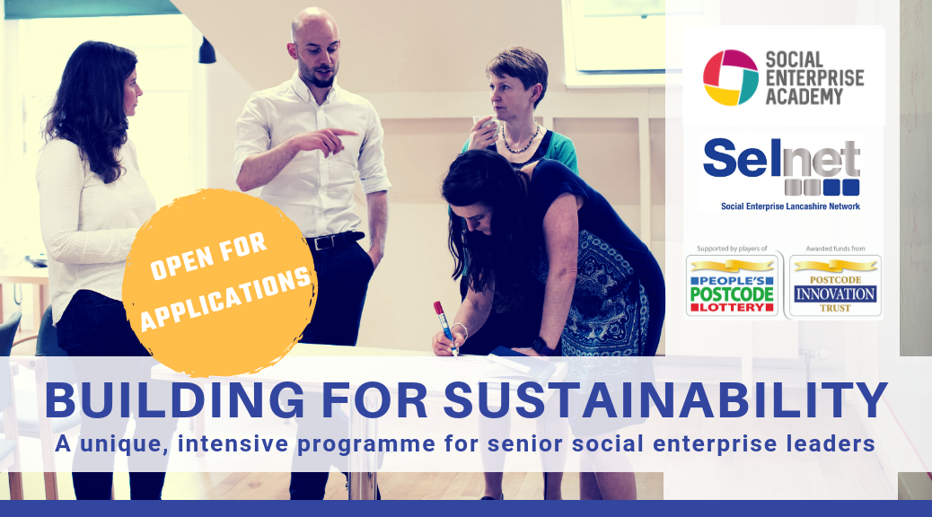
ENDS

EDITORS’ NOTES

Selnet, the Social Enterprise Network for Lancashire
The social enterprise network for Lancashire, ‘Selnet’, is the lead body representing social enterprise in the Lancashire sub-region. Selnet is a member organisation and social enterprise itself, run by its members to meet their needs.
Selnet represents Lancashire’s social business interests at national, regional and local levels through its wide network of stakeholders and partners. As the leading voice of the sector, Selnet enables Lancashire social enterprises to access support and resources to aid business development and growth.
The Building for Sustainability programme will be delivered by the Social Enterprise Academy’s learning facilitators in partnership with Selnet.
Since 2007 Selnet have been supporting social enterprises across Lancashire, Blackpool and Blackburn with Darwen to connect, develop and grow, through:
- Our vibrant, impactful membership network
- Specialist business start-up and growth advice and support
- Securing opportunities for our members
- Developing and leading partnerships
- Promotion and representation on a local, regional and national basis.
Selnet CEO Liz Tapner wins Women in Social Enterprise Award: The national awards organised by Social Enterprise UK (SEUK) shines a spotlight on the leading lights of the social enterprise community, recognising the outstanding achievements of businesses which trade for a social purpose.

Contact Selnet
For information and support please get in touch – contact the Selnet team: Call 01772 200690, email dawn@selnet-uk.com, contact us on social media: @SelnetLtd on Facebook and Twitter or go to our website www.selnet-uk.com

About Social Enterprise
Social enterprises are businesses which trade for a social purpose that reinvest or donate over half their profits to further this social or environmental mission. They are an increasingly important part of the UK economy contributing £60 billion and employing 2 million people. Estimates are there are 100,000 in the UK.
Research carried out by Social Enterprise UK, the membership body for the sector, shows they are outperforming traditional businesses when it comes to start-up rates, turnover growth and innovation. They are also ahead of the pack when it comes to workforce diversity and pay.
For more information and statistics see Social Enterprise UK’s State of Social Enterprise Report: The Future of Business and the 'Hidden Revolution' report, launched in September 2018 which showed the true scale and impact of the sector.

PROGRAMME PARTNERS
The ‘Building for Sustainability’ programme is delivered in partnership by the Social Enterprise Academy and Selnet and funded by the Postcode Innovation Trust

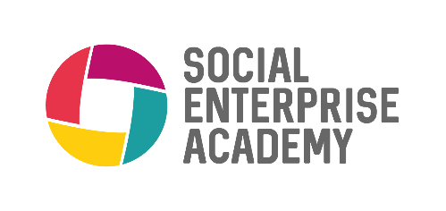
THE SOCIAL ENTERPRISE ACADEMY
The Social Enterprise Academy (SEA) is Scotland’s leading learning and development organisation supporting social change. They support people to develop themselves, their teams and their organisations to become more sustainable and have greater social impact.
The Academy’s programmes focus on leadership, enterprise, personal development and social impact measurement, and are responsive to the needs of each learner. The Academy works in partnership with networks, intermediaries and member organisations.

SELNET LTD
The social enterprise network for Lancashire, ‘Selnet’, is the lead body representing social enterprise in the Lancashire sub-region. Selnet is a member organisation and social enterprise itself, run by its members to meet their needs.
Selnet represents Lancashire’s social business interests at national, regional and local levels through its wide network of stakeholders and partners. As the leading voice of the sector, Selnet enables Lancashire social enterprises to access support and resources to aid business development and growth.

The Building for Sustainability programme will be delivered by the Social Enterprise Academy’s learning facilitators in partnership with Selnet.

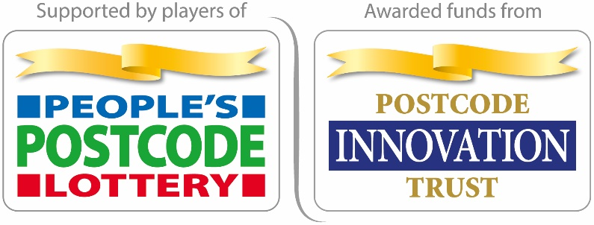
POSTCODE INNOVATION TRUST
Postcode Innovation Trust is a grant-giving body funded entirely by players of People's Postcode Lottery. It supports charities who wish to deliver innovative, impactful and engaging projects across Great Britain.
The Postcode Innovation Trust also provides support and funding to charitable organisations who support the progression of their aims.
The Building for Sustainability programme is a part of the Social Enterprise Support Programme from the Postcode Innovation Trust. The programme supports social entrepreneurs to innovate and develop solutions to the challenges that face society - breaking down barriers and helping them to increase revenues and achieve social impact.
To meet these goals, the programme involves a number of partners within the wider social enterprise ecosystem delivering programmes including; enterprise training, capacity support, accelerators, incubators, mentoring and peer support.

